K.R. MANGALAM UNIVERSITY

## THE COMPLETE WORLD OF EDUCATION



Mini Project ENSI-152

DEPARTMENT OF COMPUTER SCIENCE AND ENGINEERING SCHOOL OF ENGINEERING AND TECHNOLOGY

**TEAM LEADER**

* JAGRITI UPADHYAY - 2401730070

## TEAM CO-MEMBERS

1. PRIYA BORA - 2401730119
2. RIDHIMA SINGH - 2401730133
3. VISHU SANGWAN – 2401730090

**PROJECT INTRODUCTION AND METHODOLOGY**

# Project Overview

* A **Medicine Recommendation System (MRS)** is a tool that assists healthcare providers or patients in identifying the most suitable medications based on symptoms, diagnosis, patient history, and other factors. It leverages **data science, artificial intelligence (AI), and machine learning (ML)** techniques to improve treatment accuracy. our goal is to build such a recommendation model which will help the patients for the use of **right drugs high accuracy and efficiency** is very critical for such a recommender system

# Working Of Project

1. Our system recommend the medicine for **first care.**
2. A place where hospitals are **not available easily.**
3. For the **travelers.**
4. Use for normal or **daily based symptoms.**
5. Automating Prescription: **Reduce time and effort** in choosing the best medication.

# Methodology

1. **Data Collection and Preprocessing**  
    The initial phase involved collecting a relevant medical dataset and cleaning it using Python libraries such as **NumPy** and **Pandas**. This preprocessing included handling missing values, normalizing data formats, and preparing the data for analysis.
2. **Exploratory Data Analysis (EDA)**  
   Using **Jupyter Notebook**, various insights were drawn from the dataset to understand trends, correlations, and user needs. This helped in identifying the right features to be used for generating recommendations.
3. **Backend Development (Python + Flask)**  
   A Flask-based backend was developed to manage routing and handle user interactions. Specific Flask routes were created to process user inputs, generate medicine recommendations, and return results dynamically.
4. **Frontend Design (HTML + Bootstrap)**  
   A user-friendly web interface was designed using **HTML** and **Bootstrap** to ensure responsiveness and accessibility. The UI allows users to input symptoms or conditions and view recommended medicines.

Project Code

1. Home page

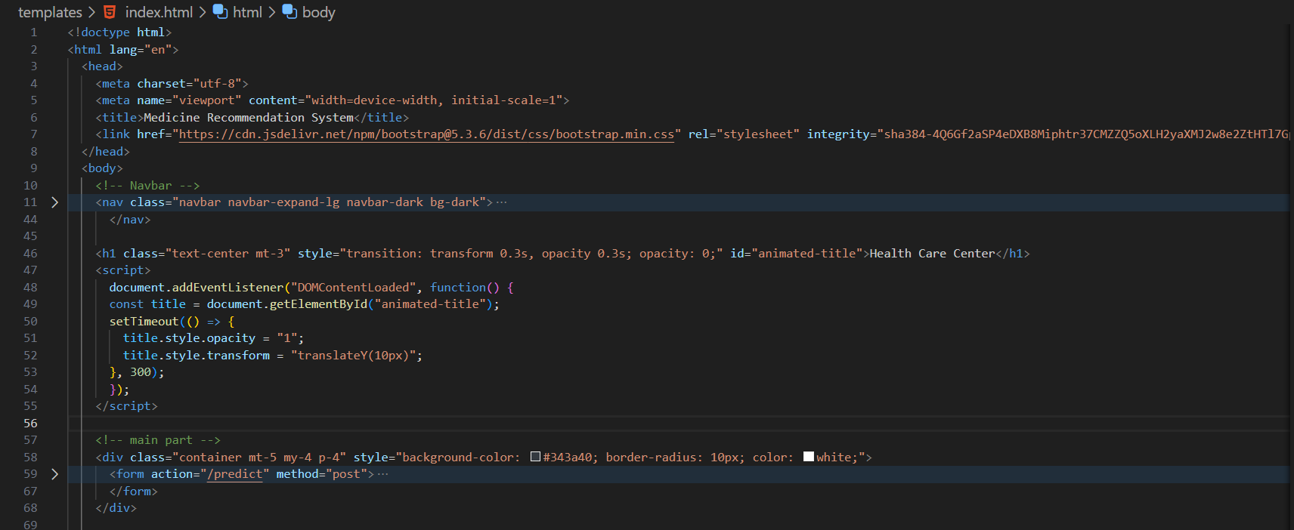

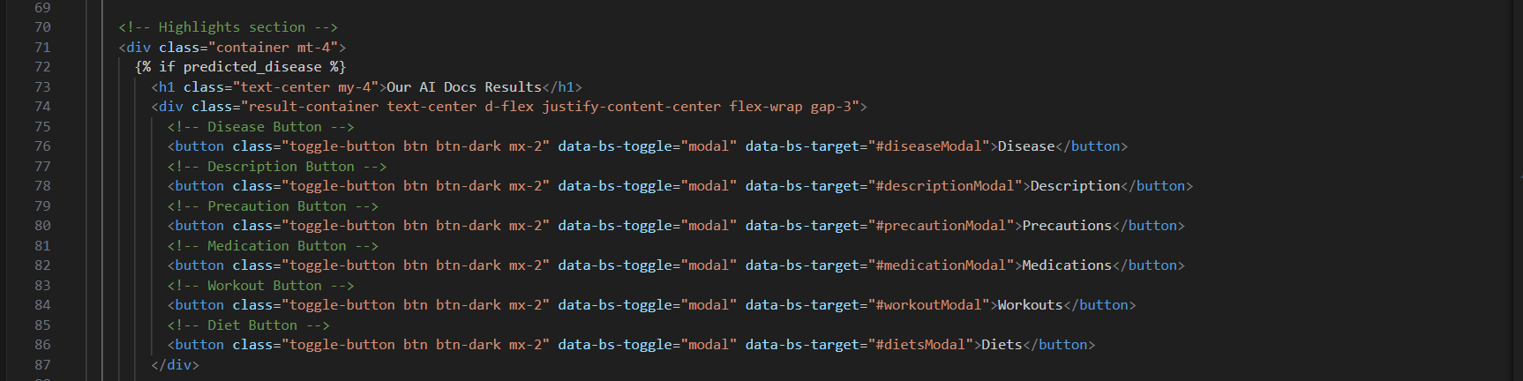

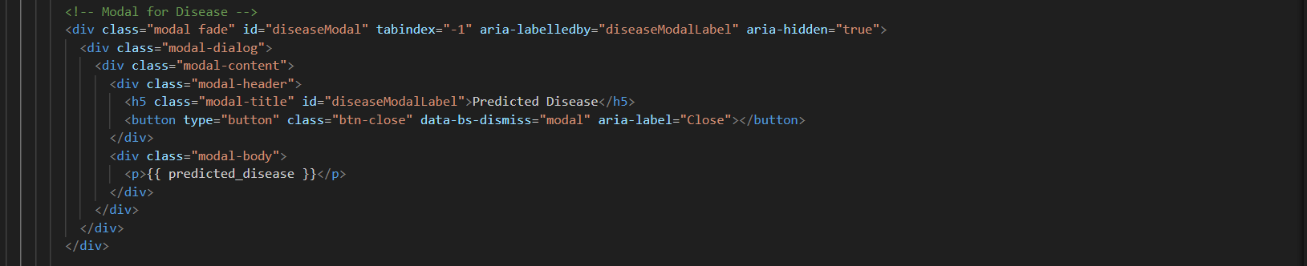

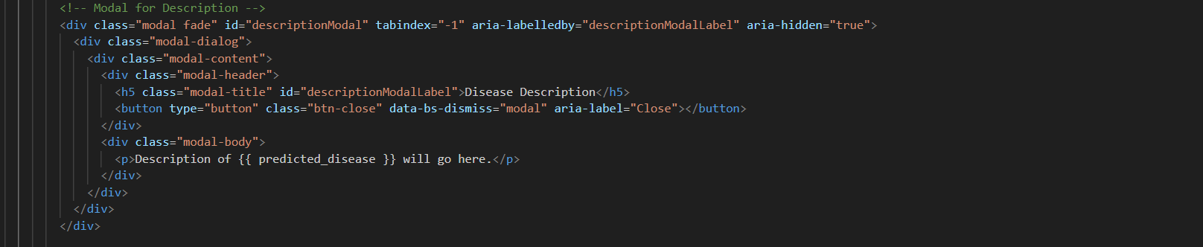

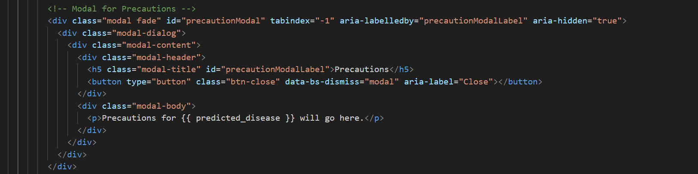

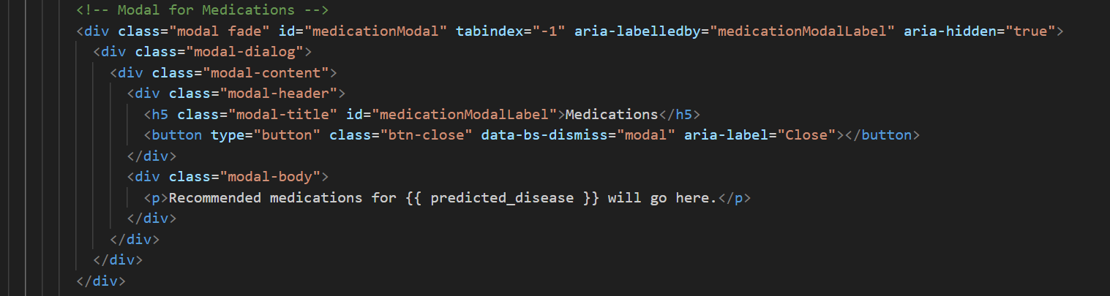

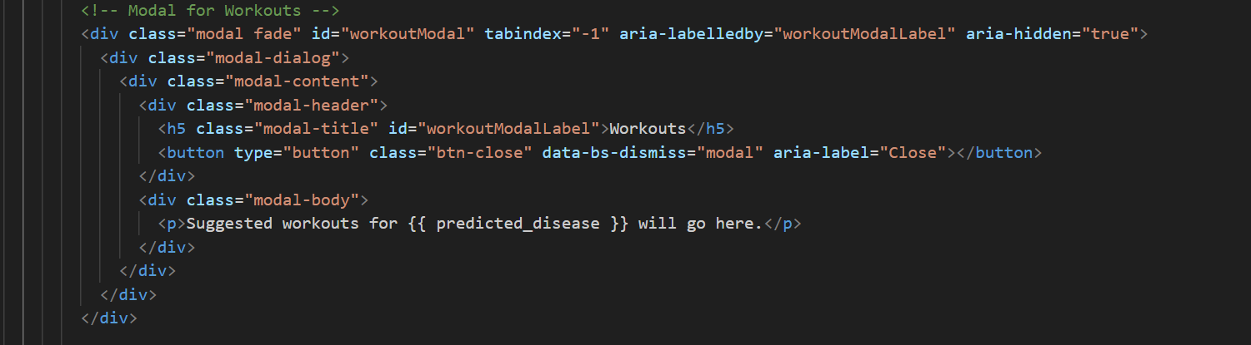

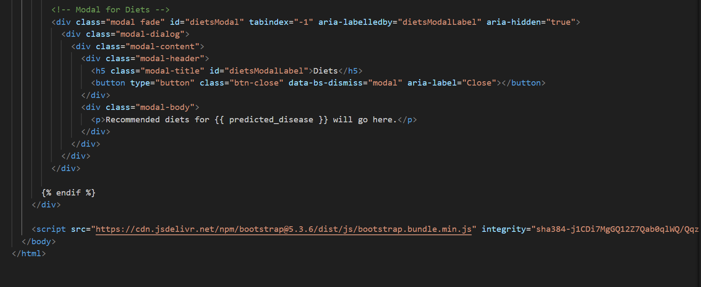

1. Main Python File

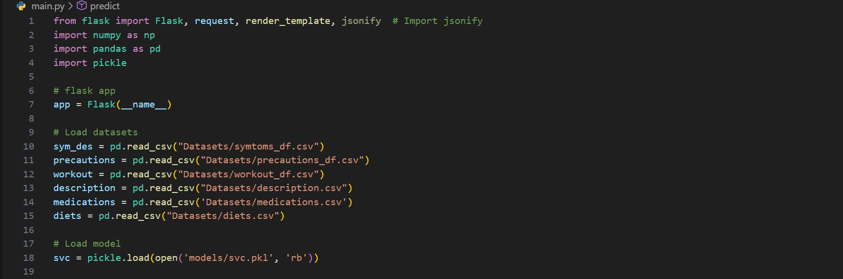

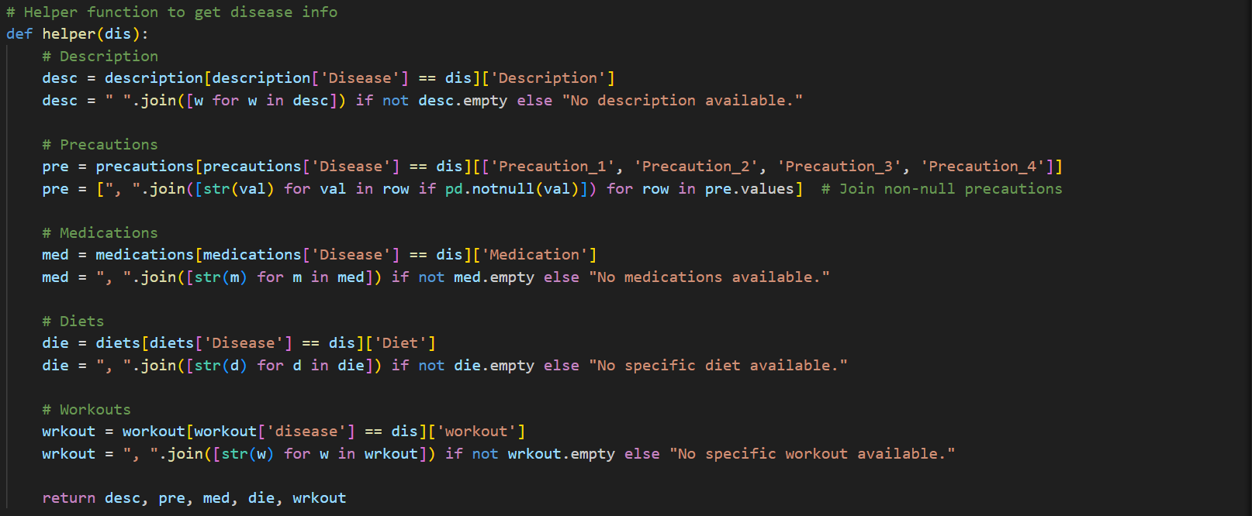

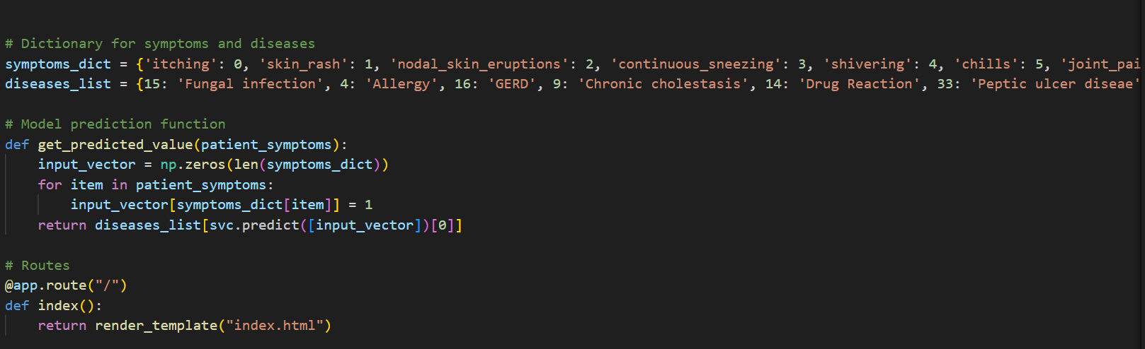

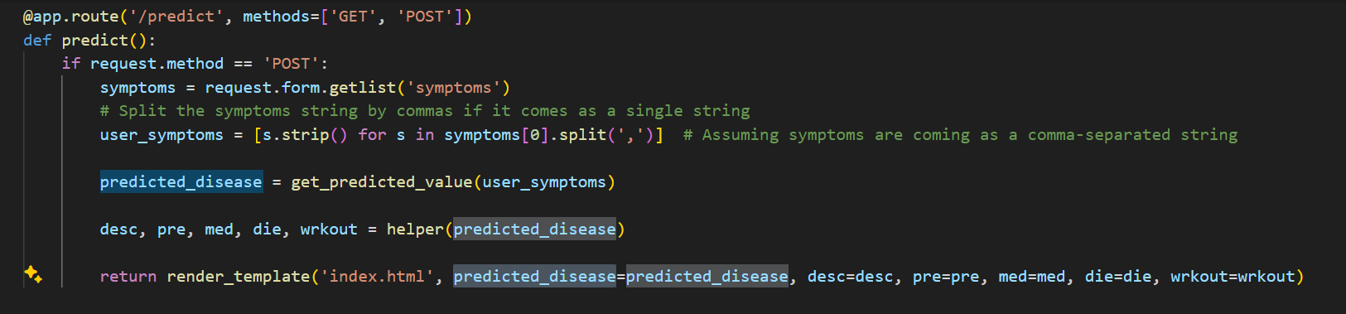

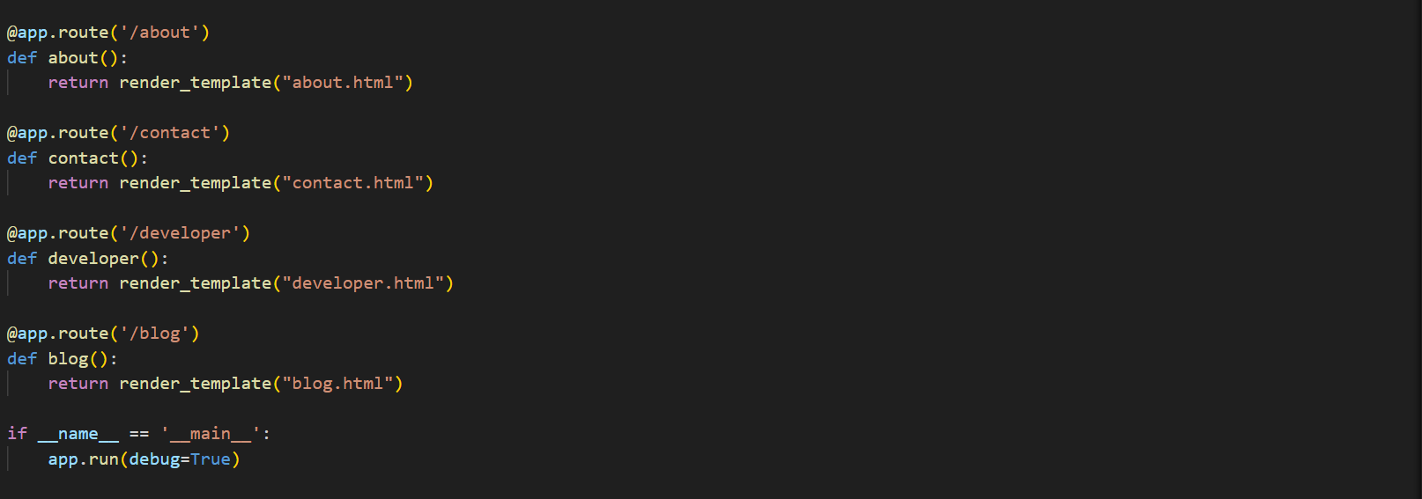

1. DATASETS

